**Acoustic Underwater Optical fiber Communication Analysis using MATLAB tool**

Yash Belliappa S T1,

1PES University,Bengaluru,India

[1yeshbelliappa@gmail.com](mailto:1yeshbelliappa@gmail.com)

2PES University,Bengaluru,India

[2anandam@pes.edu](mailto:2anandam@pes.edu)

Ananda M

PES University Bengaluru,India

2[anandam@pes.edu](mailto:anandam@pes.edu)

**Abstract.** This project introduces a novel approach to underwater optical communication technology by using Matlab tool to checkat various changes in the concentration, attenuation, SNR and Receiver power. The Matlab simulink will give us a brief idea of how the underwater optical fiber communication works at different depths. This is robust, user friendly, the efficient and powerful system to reach beyond the natural depth of the ocean so that we can do various activities like expedition. Unlike traditional methods to calculate the attentution and the SNR with fixed configurations, our innovation uses dynamic cases that accommodate a diverse range of results. The code connects to a user-friendly web interface, allowing users to find the necessary details effortlessly. Upon receiving an information the system orchestrates the Mariners and ocean expeditors accurately and promptly. This project addresses the limitations of advanced Case studies, offering a versatile and responsive solution to meet the modern underwater optical fiber communication more independent on adding external sources to reach higher depths.

**Keywords:** Matlab Tool, Reference Data, Pre-made/self-made dataset for understanding.

**1 Introduction**

Introducing a groundbreaking leap in underwater acoustic communication technology, the case study on Acoustic Underwater Communication in ocean beds revolutionizes the traditional paradigm by seamlessly integrating cloud data to help marine drives achieve the change in technology to be made with confidential and precise connectivity with the higher officials .This avant-garde approach transcends the conventional limitations of fixed configurations, ushering in a new era of dynamic adaptability. Upon the initiation of entering the prediction data through the matlab interface, the interface springs into action, leveraging the precision of input data and the flexibility according to change in concentration rate to ensure with unparalleled accuracy and promptness. This intricate dance of technology ensures that the modern underwater expeditionist’s demands for convenience and efficiency.

**2 PROTOTYPE REQUIREMENTS**

**2.1 Software Requirements**

Matlab, csv file,add-on packages.

**2.1 Hardware Requirements**

Radio-frequency type devices.

**3 DESIGN**

**3.1 Flowchart**

This flowchart starts with the user runs the program and then he has 2 chooses either plot the plot_2.m file or the other files like” Graphs, pentration_power_try, Random_noised_power gen and many more (you will see in the coming graphs) after running the files it will ask for the user input and for the user who chose the plot_2.m file it uses the dataset called “ocean_depths.csv” and plots Attenuation vs Wavelength, SNR vs Wavelength, and the surface graphs for differentating the different ocean beds. Then if the code runs sucessfully the receiver receives the result else error in the code or in the dataset same for the plot_2.m file but it depends on first generating the table of missing column results then the plot function works we use scatter, bar,surface etc. As for the other files we run it generates the results for manual meaning the user specification and we can do it for the Dataset created by the user to test the cases or else find a new Dataset from online browser and utilize that in “plot_2.m” to genrate the graphs with respect to the data parameter from the intrested column which must be a missing column and also genrate the calculation results and manually calculate to comapre the results and come to a conclusion.   
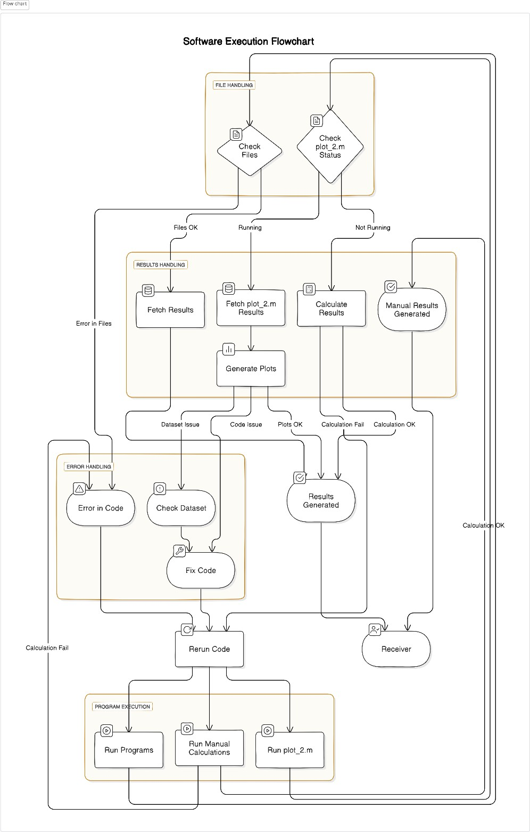

**Fig 1** Flow chart   
**3.2 Pictorial Block Diagram**

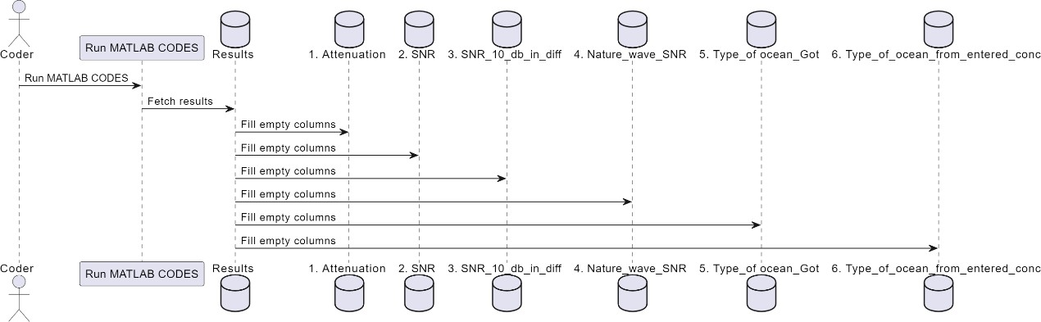 **Fig 2** Pictorial Block Diagram

**4 IMPLEMENTATION**

**4.1 Code the program**

Firstunderstand what is your requirement and also if you are doing it for a organization what is their specifications form that get a clear understanding of what all parameters are independent and dependent. Use datasheet if given because that gives the coder a glimpse on what values to work on.

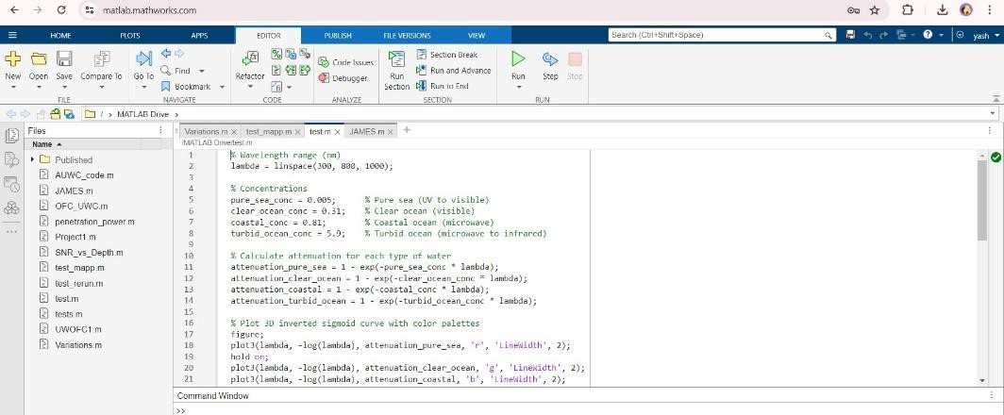 **Fig 3** example Program

**4.2 Run the files without plots**

First run the files such that we enter random wavelengths and get the SNR results and plot them. We can use the absorption and scattering coefficients to get the received power (pr), nature of the ocean beds, extinction coefficient C(λ), and the file SNR_with_Depths to calculate the SNR for different ocean beds using the depth upto 1000m and the wavelength in nm.

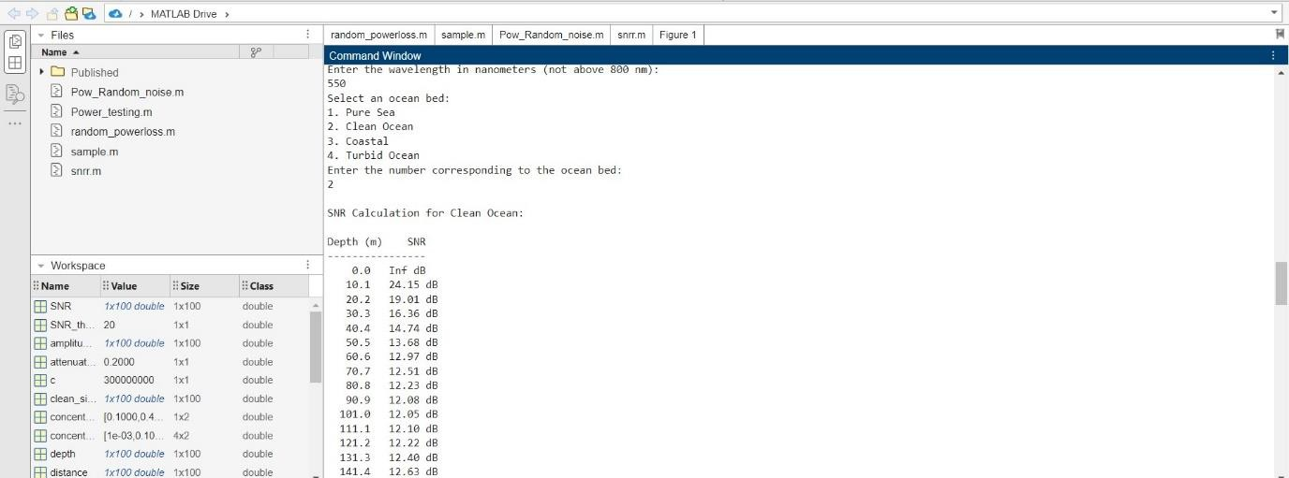

**Fig 4**  Building of conveyor belt

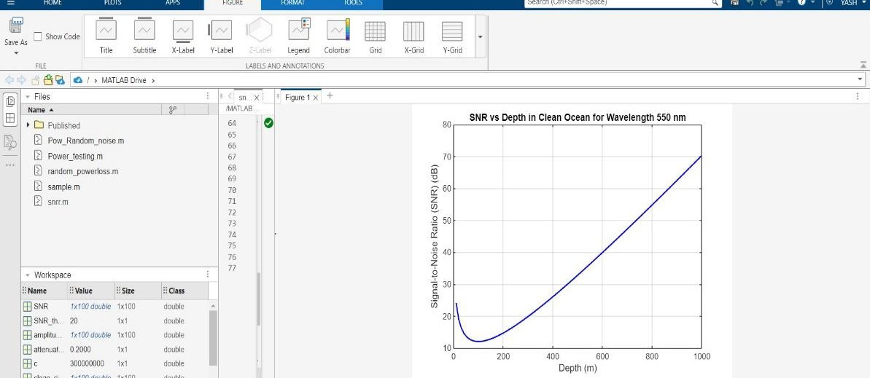

**Fig 5** Graph generated for the SNR vs Depth Random entries.

**4.3 Import Dataset**

MATLAB allows the user to import the dataset so if the coder uses the dataset he can clearly get an idea of what is the code functioning for and how it will be shown in form of graphs it will have all the user defined columns called Wavelength, depths and sometimes absorption and scattering coefficient added and the user must fetch the other empty columns like SNR, nature of the ray, nature of the wave etc using the data samples available. If you see the dataset is built already by the user and ready to perform the operation based on the mathematical logic given by the user by the users understanding and generate the results.

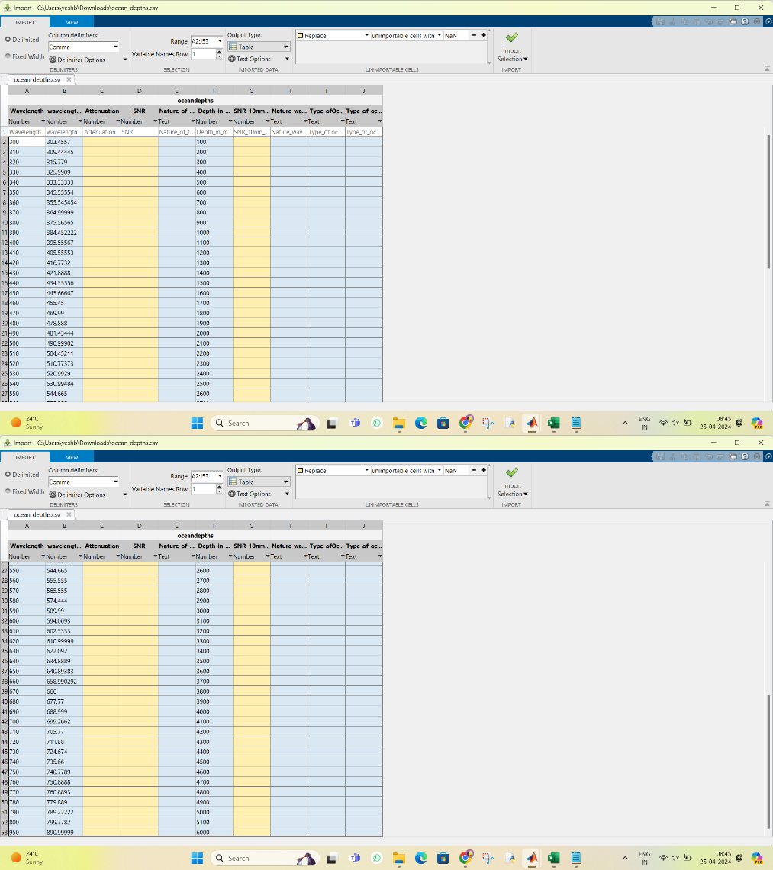

**Fig 5** Dataset Imported.

**4.4 POWER CALCULATION**

**4.4.1 Power Scope**

* + - **Total input power:** The total input power generated by using or giveing the fiber length and the wave attenuation. P_in = sum(avg_intensity) * fiber_length.
    - **Total output power:** The total output power is fetched from P_out = P_in

* exp(-fiber_attenuation_2 * fiber_length).

* + - **power loss:** P_loss = P_in - P_out; % Power loss during transmission.

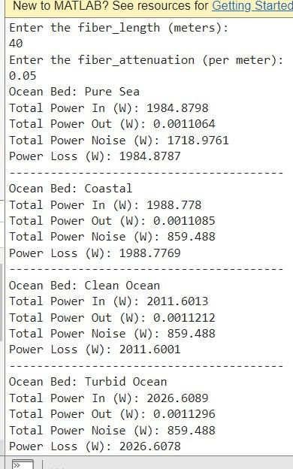

**Fig 6 Power factors for each ocean bed.**

**5 RESULTS**

**5.1 Working Cases**CASE 1: SNR for each Ocean Beds

From the below graph we can observe that the intensity part of each ocean bed within this analysis process can be omitted and well driven for extraction of data required for building the ships or submarines with special features. The black lines indicate there is no information(SNR fetched) This can happen due to disruption of the signal, low attenuation and low intensity.

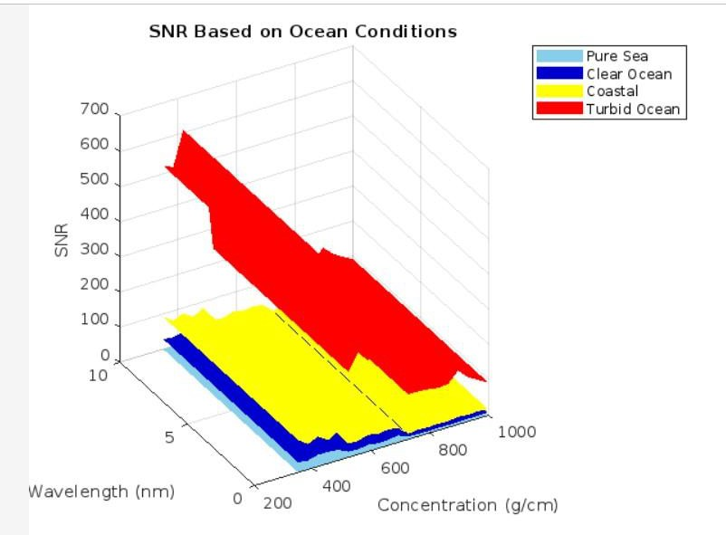  
 **Fig 7** SNR based on concentration ocean beds

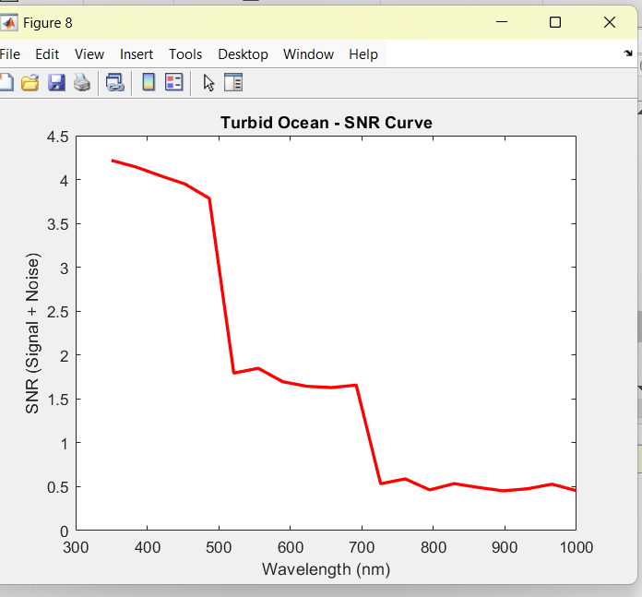

**Fig 9** SNR Curves with different ocean beds with and without noise and their LOC structure.

.

**6 CONCLUSION AND FUTURE SCOPE**

**6.1 SCOPE**

From the below graphs observe the changes in curves for each ocean beds due to noise and concentration rates that changes from depth to depth.In the near future these graphs will change for someother aspects included.

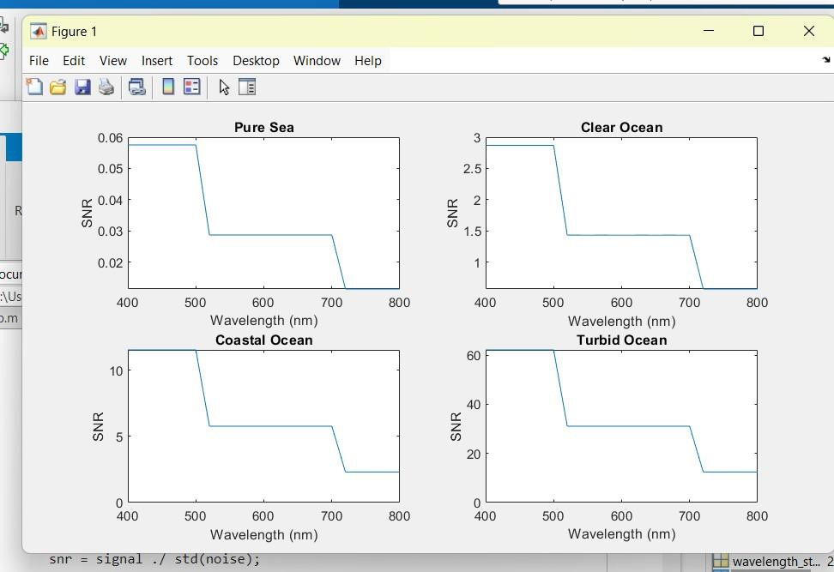

**Fig 8:** Clean graph

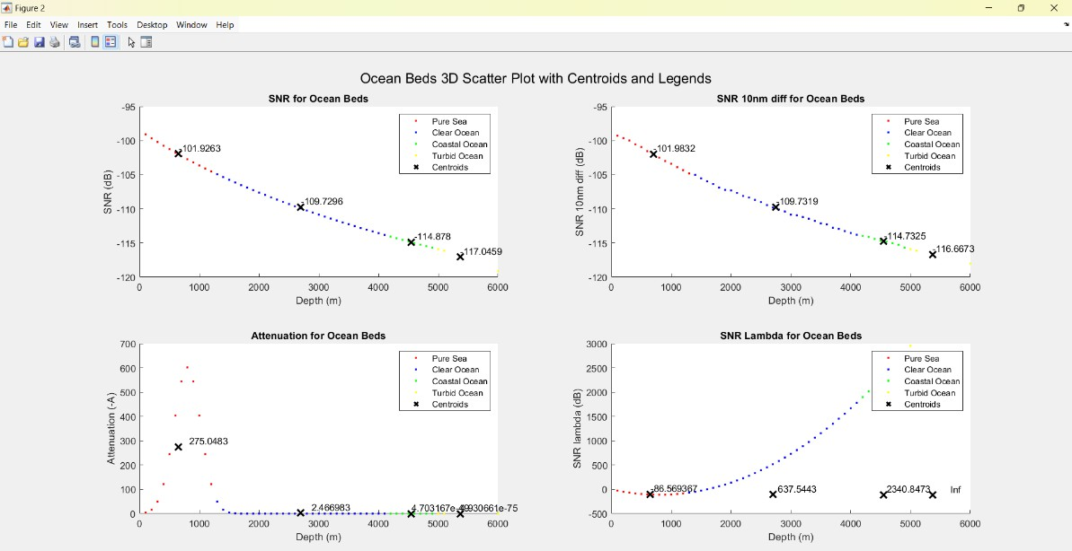

**Fig 9:** Ocean beds categorization

**CONCLUSION**

From these results we can conclude and get an understanding about how our parameters like SNR, BER, Attenuation, Nature of the ray many other is effected by the length of the fiber, the wavelength, Temp and many other factors either directly or due to addition of parameters and value like the values of h,c,lambda etc.

**ACKNOWLEDGMENT**

We would express my gratitude to Dr Ananda M, Associate Professor, Electronics and Communication Engineering, PES University, for his guidance, assistance, and encouragement throughout the development of this work. We thank PES University for providing us the required support at the right time. Finally, we thank our family and friends for their contionous support.

**REFERENCES**

1. Underwater wireless-to-plastic optical fiber communication systems with a passive front end by Amjad Ali; Chao Zhang; S. A. Hassnain; Weichao Lyu; Riffat Tehseen; Xiao Chen
2. Underwater Optical Communications: A Brief Overview and Recent Developments by Saleha Al-Zhrani,Nada M. Bedaiwi, Abeer Barasheed, Intesar El Ramley.
3. Real-Time Underwater Wireless Optical Communication System Based on LEDs and Estimation of Maximum Communication Distance by Minglun Zhang and Hongyu Zhou
4. Bridging optical fiber communication and underwater wireless optical communication via third harmonic generation by Haiwu Zou, Chao Zhang, Zihao Du, Xiyin Wang, Haipeng Wang, Guangbin Song, Yufan Zhang, Hao Zhang, Yunhai Gao, Bo Wu, Shiming Gao, and Jin Xu.
5. Underwater Communication: A Detailed Review by Suresh Kumar
6. Underwater Optical Wireless Communication by Hemani Kaushal; Georges Kaddoum
7. Underwater Optical Wireless Communications by Giuseppe Schirripa Spagnolo, Lorenzo Cozzella, and Fabio Leccese.
8. High-Speed Underwater Optical Wireless Communication with Advanced Signal Processing Methods Survey by by Chengwei Fang 1,Shuo Li , Yinong Wang and Ke Wang
9. Underwater optical wireless communications, networking, and localization: A survey by Nasir Saeed, Abdulkadir Celik, Tareq Y. Al-Naffouri, Mohamed-Slim Alouini.
10. Underwater optical wireless communication system performance improvement using convolutional neural networks by Omar Nameer Mohammed Salim, Salah A. Adnan ,Ammar Hussein Mutlag
11. S. A. Adnan, A. Alchalaby, and H. A. Hassan, “Future optimization algorithm to estimate attenuation in 532 nm laser beam of UWOC-channel: Improved neural network model,” Math. Modell. Eng. Problems 8, 453 (2021).
12. X. Zhou and J. Yu, “Digital signal processing for coherent optical communication,” in 2009 18th Annual Wireless and Optical Communications Conference, (IEEE, 2009), pp. 1–5.
13. J. Zhao, Y. Liu, and T. Xu, “Advanced DSP for Coherent Optical Fiber Communication,” Appl. Sci. 9(19), 4192 (2019).
14. K. Kikuchi, “Fundamentals of Coherent Optical Fiber Communications,” J.Lightwave Technol. 34(1), 157–179 (2016).
15. P. Tian, X. Liu, S. Yi, Y. Huang, S. Zhang, X. Zhou, L. Hu, L. Zheng, and R. Liu, “High-speed underwater optical wireless communication using a blue GaN-based micro-LED,” Opt. Express 25, 1193 (2017).
16. J. Wang, C. Lu, S. Li, and Z. Xu, “100 m/500 Mbps underwater optical wireless communication using an NRZ-OOK modulated 520 nm laser diode,” Opt. Express 27, 12171 (2019).
17. S. Adnan, M. Ali, and F. Hakwar, “The air bubbles effect for underwater optical wireless communication using 650 nm wavelength,” Eng. Technol. J. 37, 398 (2019).
18. S. A. Adnan, H. A. Hassan, A. Alchalaby, and A. C. Kadhim, “Experimental study of underwater wireless optical communication from clean water to turbid harbor under various conditions,” Int. J. Des. Nature Ecodyn. 16, 219 (2021).
19. S. A. Adnan, A. Alchalaby, and H. A. Hassan, “Future optimization algorithm to estimate attenuation in 532 nm laser beam of UWOC-channel: Improved neural network model,” Math. Modell. Eng. Problems 8, 453 (2021).
20. Towards underwater coherent optical wireless communications using a simplified detection scheme by XINKE TANG, RUPESH KUMAR, CAIMING SUN, LONG ZHANG, ZHEN CHEN, RUI JIANG, HONGJIE WANG, AND AIDONG ZHANG.